Higher National Diploma in Information Technology
HNDIT11062 – Web Development
First Year- Semester I

Lab Activity 08
- View the output of the following HTML codes.
- Ordered list
<html>
<body>
<b>An ordered list with numbers (default):</b>
<ol>
<li>Telephone</li>
<li>Cellular phone</li>
<li>Television</li>
</ol>

<b>An ordered list with lowercase letters:</b>
<ol type="a">
<li>Telephone</li>
<li>Cellular phone</li>
<li>Television</li>
</ol>

<b>An ordered list with uppercase letters:</b>
<ol type="A">
<li>Telephone</li>
<li>Cellular phone</li>
<li>Television</li>
</ol>

<b>An ordered list with lowercase roman numerals:</b>
<ol type="i">
<li>Telephone</li>
<li>Cellular phone</li>
<li>Television</li>
</ol>
<b>An ordered list with uppercase roman numerals:</b>
<ol type="I">
<li>Telephone</li>
<li>Cellular phone</li>
<li>Television</li>
</ol>
</body>
</html>
- Unordered list

<html>
<body>
<b>An unordered list with disc bullets (default):</b>
<ul type="disc">
<li>Telephone</li>
<li>Cellular phone</li>
<li>Television</li>
</ul>

<b>An unordered list with square bullets:</b>
<ul type="square">
<li>Telephone</li>
<li>Cellular phone</li>
<li>Television</li>
</ul>

<b>An unordered list with circle bullets:</b>
<ul type="circle">
<li>Telephone</li>
<li>Cellular phone</li>
<li>Television</li>
</ul>
</body>
</html>

- Definition list
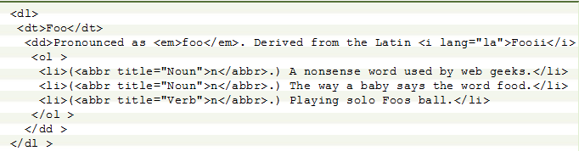

- Links within same page
<html>
<body>
<a name="top"></a>Click <a href="#bottom">here</a> to jump to the bottom of the page
<p>Some text</p>
<p>Some text</p>
<p>Some text</p>
<p>Some text</p>
<p>Some text</p>
<p>Some text</p>
<p>Some text</p>
<p>Some text</p>
<p>Some text</p>
<p>Some text</p>
<p>Some text</p>
<p>Some text</p>
<p>Some text</p>
<p>Some text</p>
<p>Some text</p>
<p>Some text</p>
<p>Some text</p>
<p>Some text</p>
<p>Some text</p>
<p>Some text</p>

<a name="bottom"></a>
Click <a href="#top">here</a> to jump to the top of the page
</body>
</html>

- Links in a new window
<html>
<body>
<a href="http://www.yahoo.com" target="_blank"> Go to Yahoo </a><br><br>
<a href="http://www.w3schools.com/html/default.asp" target="_blank"> Go to W3Schools Online Web Tutorials page </a>
<p>
You can open links in a new window by setting the <b>target</b> attribute to "_blank".
</p>
</body>
</html>

- Create web pages to display followings.
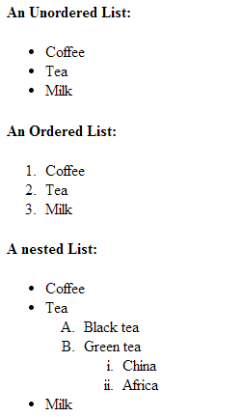

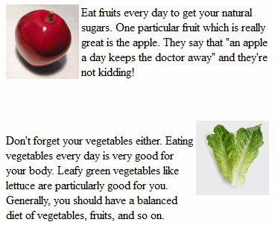

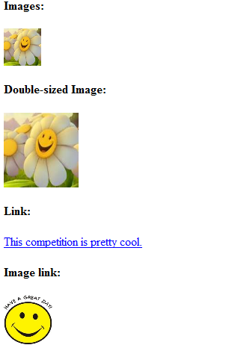

Link to the web page created in question 2 (I)

Link to the web page created in question 2 (II)

- Definition list
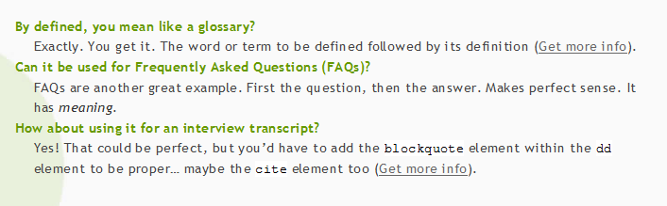

- Create links to five different pages on five different websites that should all open in a new window.
- Display an image that when clicked will link to itself and will display the image in the browser by itself.

